**Lesson 10 Demo 01**

**react-simple-test**

**Objective:** To demonstrate the simple test with inbuild jest testing configuration.

**Tools required:** Node JS and React JS

**Prerequisites:** HTML, CSS, JavaScript ES5/ES6, Basic React Concept

**Note** : All react js project already created with version 18.x with Sample App.js file

**Steps to be followed:**

1. Set up for react jest js project
2. verify testing dependencies in package.json file
3. Verify app.js component and app.test.js testing file
4. Now we test the application.

**Step 1: Set up for next js project**

1. Open the terminal window inside the **react-simple-test** folder

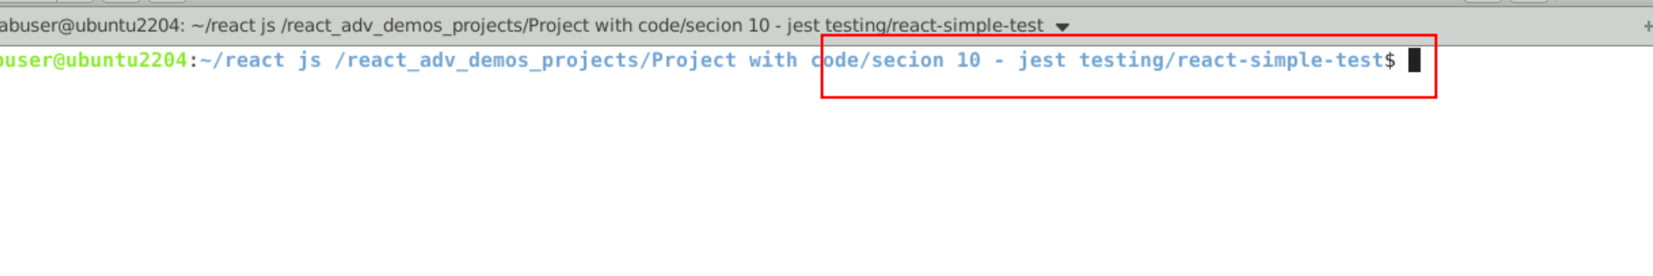

1.2 run npm install to download the dependencies.

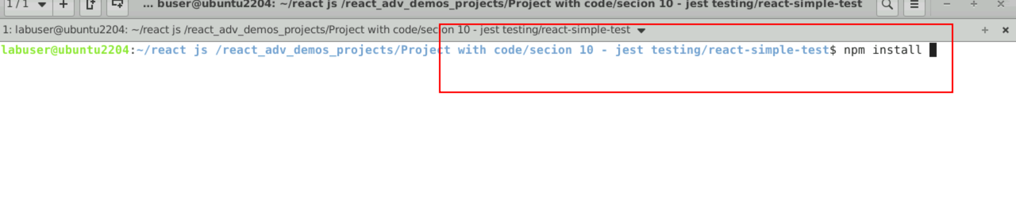

* 1. Open the project in VS code

Note: short cut to open write **code .**

* 1. view the project structure

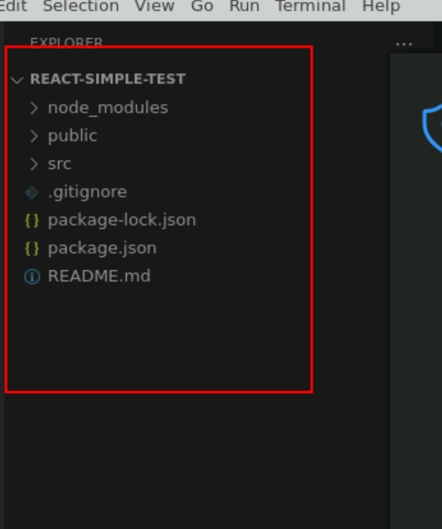

**Step 2 : verify testing dependencies in package.json file**

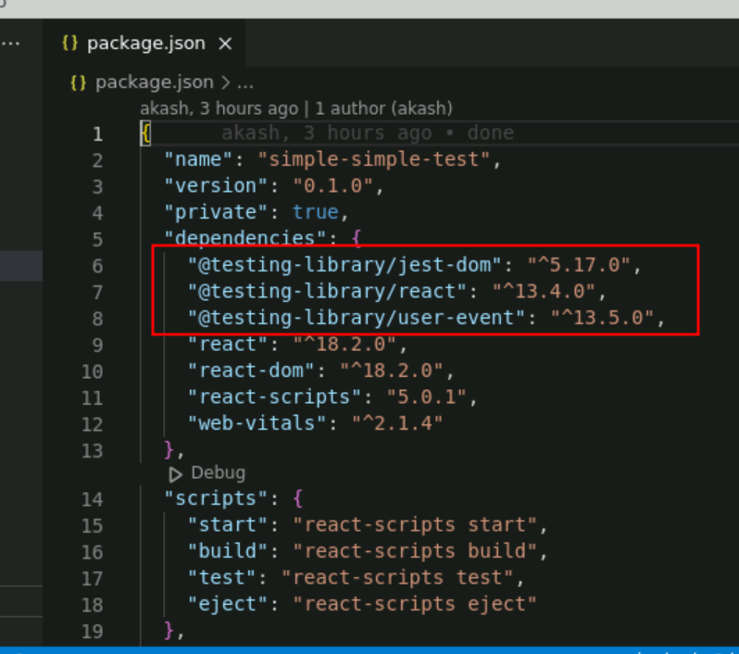

**Step 3:** Verify app.js component and app.test.js testing file

3.1 App.js component code

import logo from './logo.svg';

import './App.css';

function App() {

return (

<div className="App">

<header className="App-header">

<img src={logo} className="App-logo" alt="logo" />

<p>

Edit <code>src/App.js</code> and save to reload.

</p>

<a

className="App-link"

href="https://reactjs.org"

target="_blank"

rel="noopener noreferrer"

>

Learn React

</a>

</header>

</div>

);

}

export default App;

3.2 for this component react js provide sample testing file ie App.test.js file. This file take the help of @testing-library/react module and test the contain present in jsx.

import { render, screen } from '@testing-library/react';

import App from './App';

test('renders learn react link', () => {

render(<App />);

const linkElement = screen.getByText(/learn react/i);

expect(linkElement).toBeInTheDocument();

});

**Step 4 : Now we test the application**

4.1 open the terminal inside the project and run the application we need to use the command as

**npm test**

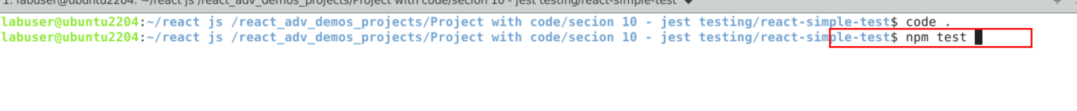

4.2 You can view the output on console.

